Chapter 11 – The Rope Experiment and Finite Point Geometry

Overview
This ground-breaking chapter takes a radical look at mathematical concepts inherent in flow measurement and proposes alternative theories that avoid the contradictions of traditional geometry. We explore geometry from a new perspective and develop the fundamentals of a new geometry called Finite Point Geometry. In this new geometry we show how to derive a rational value for calculating the circumference and area of a circle rather than treating pi (π) as an irrational number that has an infinitely non-repeating decimal. In the process we challenge the father of geometry, Euclid, and his foundational belief that points have location but no extension or area, and we provide a solution to the resulting Zeno’s Paradox. In addition, through a new spin on calculus, we offer a fresh approach to tackling one of the most difficult tasks for a traditional geometry based primarily on straight lines: measuring the area under a curve.
We dive deeply into these concepts in the following sections:
- An overview of geometry as a branch of mathematics
- Euclid’s views on points and the number line
- Euclid’s views on points and lines generate Zeno’s Paradox and other paradoxes
- The prevailing solution to Zeno’s Paradox
- Where Zeno goes wrong
- Measurement requires a unit of measurement and a level of precision
- Points lie on the line, not in the line
- How many points lie on the line
- From length to area: Measuring the area of a circle
- Why we need π in the first place
- The role of π in calculating the area of a circle
- The Rope Experiment
- The length of a rope doesn’t change when you lay it flat
- The area of a circle is a rational number
- Measuring flow in round pipes
- Application to mass flow
- Calculus and measuring the area under a curve
We begin by placing geometry in the context of mathematics, then discuss the obvious but important fact that making a measurement requires a unit of measurement and a level of precision. We explore the relationship between points and lines, and propose that points lie on the line, not in the line.
We look back on how π originated and the various attempts to determine its value. A diagram shows that r² is a square and that, the formula for the area of a circle, π * r² , is essentially finding how many squares will fit into a circular area. We conclude that the answer appears to be no finite number.
The Rope Experiment section then shows that the value of the circumference of a circle is rational. The experiment essentially takes the circumference of a circle and lays it into a flat line, which of course doesn’t change the length of the rope. As a flat line, the length can be measured with a ruler or tape measure, and there is no need for π. We can measure the value of π as 3.1416, or we can carry out the value to any level of precision. The value 3.1416 is not the beginning of an infinite series of nonrepeating numbers; it is a rational number that is determined by measurement.
If we substitute C/d for π in the formula for the area of a circle (πr²⁾, we get (C/d) * r². Because C is now rational by the rope experiment, and we know that the diameter is rational in most situations, it follows that the area of a circle is a rational number. This is a dramatic change from the traditional interpretation of πr^{2,} according to which the area of a circle is an irrational number with an infinitely non-repeating decimal.

Geometry as a Branch of Mathematics
In many ways, mathematics is the language of science. Mathematics displays abstract relationships that may not be apparent to an ordinary observer. None of the tools and objects we rely on for our daily life, such as planes, trains, automobiles, computers, clocks, flowmeters, and cellphones would be possible without mathematics. Mathematicians, scientists, and philosophers have spent many centuries developing different branches of mathematics including arithmetic, geometry, algebra, calculus, trigonometry, number theory, probability and statistics. Political polling, bridge building, housing construction, traffic control, space travel, and many other features of our daily lives rely on different branches of mathematics.
Geometry is one of the most central and fascinating branches of mathematics. Geometry is the branch of mathematics that studies the sizes, shapes, properties, and relationships of points, lines, surfaces, solids, and fluids. Geometry studies not only the dimensions of the objects of our ordinary experiences, it also describes relationships among abstract entities that these objects represent. For example, there are many square and rectangular objects in the world. Geometry can tell us how to find the areas of those objects by using formulas that apply to any object of that shape. For example, to find the volume of a rectangle, multiply:
Length x Width x Height.
This is a formula that applies to any rectangle, regardless of what it’s made of, its size, color, height, etc. Geometry gives us abstract formulas and equations that apply to many different objects of a certain shape, independent of their other qualities. This is part of the power of geometry.
Much of our geometry goes back to the early Greeks, in the period around 300 B.C. This is the time when Euclid lived. Euclid is sometimes called “the father of geometry.” He earned this title through his rigorous axiomatic method, and his geometric proofs. Euclid is the author of “Elements,” a 13-book work that lays out his definitions, axioms, theorems, and proofs, along with his study of the properties of lines, triangles, circles, squares, and other geometric shapes. It is to him that we owe our concept of point. Euclid’s definition of “point.”
Euclid’s definition of “point” is “that which has no part.” This means that a point has no length, width, or breadth. A point has location only and does not have size or dimension. This is the concept of a point that Euclid laid out around 300 BC, and it is still the dominant definition of a point 2,800 years later.

Euclid’s Views on Points and the Number Line
The distance between two points is often represented as a line. This line can be straight or curved, depending on the location of the points. Many attempts have been made to define the continuum that is a line. The traditional Euclidean view is that a continuous line is made up of discrete points, and that another point can be placed between any two points. This means that a line is dense, and there is no limit to the number of points that can be drawn in the line. In fact, in the Euclidean view, a line is made up of infinitely many points. These points are conceived of as having location only, with no area.
The relation between discrete points and continuous lines typifies some mathematical puzzles that have been discussed for thousands of years and are still discussed today. Continuous lines and discrete points are fundamentally different in nature and it is not clear whether it can be correct to analyze continuous lines as being made up of discrete points, even if there are very many of them. Here the idea of infinity is brought in to be a kind of metaphysical glue. The idea is that if there are infinitely many discrete points, then these points, when packed densely enough, form a continuum, which then somehow adds up to continuity. But it is not clear how arealess points can somehow make up a continuous line, even if there are infinitely many of them.
A similar problem occurs with analyzing the area under a curve. This problem is addressed by calculus, which was independently invented by Newton and Leibnitz in the late 1600s. According to calculus, this area is determined by drawing a series of rectangles that more and more closely approximate the curved area. As these rectangles become smaller, the sum of their areas more closely approximates the curved area. As the widths of the rectangles, which become more and more numerous, approach zero, the sum of the areas of the rectangles equals the area under the curve. This sum is conceived of as the limit of an infinite series of rectangles that are ever diminishing in width.

Euclid’s View on Points and Lines Generates Zeno’s Paradox and Other Paradoxes
Analyzing a continuous line as being made up of infinitely many discrete points isn’t necessarily wrong, and this idea has been accepted for thousands of years. It does raise some paradoxes, however, which need to be dealt with in some way. Some of these are called “paradoxes of motion,” and they were formulated by a Greek philosopher named Zeno of Elea around 450 B.C. It is believed that Zeno preceded Socrates by about 20 years.
Zeno may have formulated as many as 40 paradoxes, but only 10 are known. One involves Achilles and a tortoise, and it gives an analysis of motion that purports to show that Achilles, a fast runner, can never catch up to the tortoise, provided the tortoise is given a head start.
Another paradox, well enough known to be called Zeno’s Paradox, has a similar logic and involves the idea that motion is impossible. To understand this paradox, consider someone attempting to move from Point A to Point B. First, he must go halfway from A to B, which we can call A′. To move from A′ to B, he then has to go halfway again to B, to a point we can call A′′. However, he is still not at B, since he must go halfway again, ad infinitum. So, no one ever actually gets to point B, and hence motion is impossible.
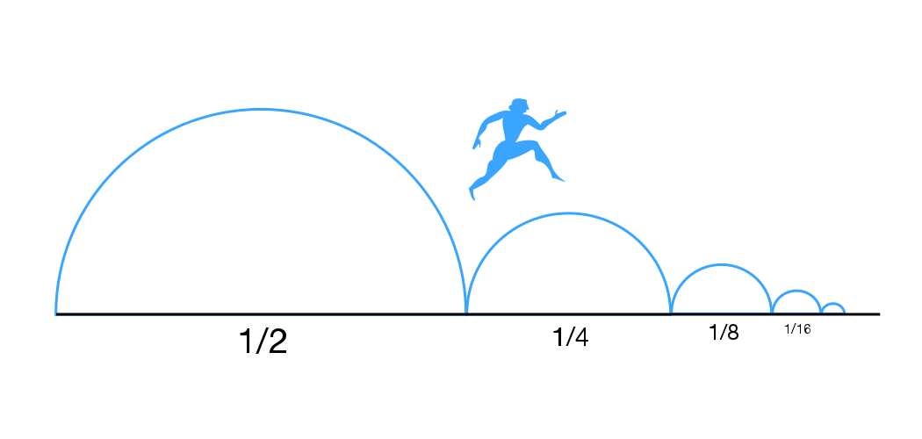
Figure 11-1. An illustration of Zeno’s Paradox

Consider the concept of a point as a dimensionless mathematical object with no area, which is based on the Euclidean view of the number line. As discussed previously, in Euclidean geometry, a line is made up of infinitely many arealess points. It is always possible to put another point between any two points.
What makes Zeno’s Paradox seem plausible is that the person who is going from Point A to B is conceived of as being located at an arealess point. Since it is always possible to put another point between any two points, he never reaches destination B.

The Prevailing Solution to Zeno’s Paradox
What is the correct solution to Zeno’s Paradox? The prevailing contemporary solution relies on concepts from set theory developed by Bernard Balzono, Richard Dedekind, Georg Cantor and others. According to this view, Zeno’s series of points is no longer considered to be potentially infinite. Instead, it accepts the idea of an infinite set of points and analyzes Zeno’s series of points as an infinite set of points that converge to a limit. Instead of viewing the set of path lengths or points that is 1/2 + 1/4 + 1/8 + 1/16 + etc. as an infinity that can never be traversed, this analysis views it as a series that converges to 1. This idea of a set of points that converge to a limit is similar to the idea of a series of rectangles of diminishing width that converge to a limit of zero and is used in contemporary calculus to analyze the area under a curve.

Where Zeno Goes Wrong
Where does Zeno’s paradox go wrong? This paradox only works because the person involved is considered to be at a dimensionless point. Once the person is considered to be at a mathematically dimensionless point and at a position not taking up area, it is not possible to refute Zeno’s paradox. This is because it will always be possible to specify a dimensionless point between the point where our traveler is located and his endpoint.

Infinity, a Kind of Metaphysical Glue
Euclidean geometry neglects a simple mathematical distinction in analyzing what a line is. According to this geometry, points do not lie on the line, they lie in the line. A line, as we’ve said, is conceived of as being made up of infinitely many dimensionless points. Conceiving of points as lying in a line requires the introduction of the concept of infinity, since there appear to be infinitely many points in a line. Set theorists have also created different infinities of different sizes. The concept of infinity is a kind of metaphysical glue that is required to analyze a continuous phenomenon such as a line in terms of discrete arealess points. There is no way to build up to the concept of continuity when it is being analyzed in terms of discrete points without introducing the concept of infinity.

Measurement Requires a Unit of Measurement and a Level of Precision
When people make a length measurement, they are implicitly relying on a unit of length measurement, whether it is inches, miles, meters or kilometers. And that measurement unit has to be defined in terms of a standard for that unit, otherwise the measurement unit cannot serve as an objective standard of measurement. When the human foot was the standard by which the length of a foot was judged, but there was no objective foot length to serve as the standard, the foot unit referred to different lengths. When a “standard” foot length was inscribed at St. Paul’s Church in the 1100s, this was a first step toward defining an objective standard for the length of a foot.
The concepts of length and distance are closely related. Length is the measurement of the distance between two points. As long as the measurement is being made in feet or inches, then feet or inches are the smallest allowable units of measurement for the purpose of this measurement.
Every measurement is made to some degree of precision. The term “precision” refers to the number of digits to which a measurement is made. A measurement is not absolute; it is relative to the unit of measurement and to the degree of precision required for the measurement.
While there is no theoretical limit to the degree of precision of any measurement, this does not mean that the degree of precision attainable is infinite. It is simply unlimited in the sense that it can be taken as far as the need requires and technology allows. It is not infinite in the sense that the precision of measurement can go to infinity. One way that Zeno’s Paradox goes wrong is that it involves constantly shifting the level of the precision regarding where a person is located.

Points Lie on the Line, Not in the Line
Anyone who pays attention to our language will realize that we speak of points being on a line more naturally than of points being in a line, or in part of a line. The idea that points are in a line is more a result of mathematical analysis than of understanding the language of mathematics. But what is the difference between points being on a line and points being in a line?
Someone who is sitting on a fence is not part of the fence; instead, his body is physically touching the fence. But no one would think that a person sitting on a fence is part of the fence. Instead, the fence is made up of wood, steel, rocks or some other material, depending on the type of fence. Likewise, a book lying on a table is not part of the table, although the book touches the table.
Intuitively, it makes sense to say that points lie on a line. When we draw a point on a line, the line is typically there first, and we physically mark the point on top of the line. We might mark the point with an “X” (X marks the spot), with a round dot or with a little perpendicular line. However it is marked, it would be unusual to conceive of this “X,” round dot or perpendicular line as somehow being a part of the line, while it is perfectly natural to think of the X, round dot or perpendicular line as lying on the line.
If points lie on the line rather than in the line, there is no need to introduce the concept of infinity to describe how many points there are. This is because a group of points lying on a line are not continuous; instead, they are simply a group of discrete points that are related by all being on the same line. It is the line that is continuous, but since discrete points are not part of a continuous line, they in themselves are not part of the continuous phenomenon.

A Line Is the Path of a Moving Point
What is the relationship between points and a line? As Aristotle says in De Anima 1:4, a line is the path of a moving point. Likewise, a plane is the path of a moving line. A point and a line then are intimately related, but not in the way Euclidean geometry thinks of them as being related. A line is somewhat like the trail of a meteor, except that when we draw a line using the point of a pencil, the line is static and remains visible.

How Many Points Lie on a Line?
If we cannot analyze a continuous line as an infinite set of arealess points, how should it be analyzed? We have already said that points lie on the line but should not be considered part of the line. In this analysis, it makes sense to think of points as discrete units that sit on the line. If it is the number line that is being considered rather than a line that consists of the distance between two points, then these points can be considered as dimensionless in the Euclidean fashion. Euclidean mathematicians will consider these as representing an infinite number of points. In a non-Euclidean analysis, these points will have area. This area will vary with the unit of measurement that is specified. The Euclidean analysis doesn’t reintroduce Zeno’s Paradox with points lying on the line, as long as these are not conceived as representing the location of three-dimensional objects.
If we conceive of points as having area, no matter how small, and as sitting on the number line rather than being a part of it, then there is no possibility of introducing Zeno’s Paradox. For example, consider how many points exist between 0 and 1 on the number line. If each point is defined as having a width of 1/1000 of an inch where the distance between 0 and 1 is considered to be one inch, then there are 1000 points between 0 and 1. If someone is considered to be located at one of these points, Point A (for example, point 200), and wants to go halfway to Point B, which is 1, he will go to point 600. From there, to again go halfway to Point B, he will go to point 800, then to point 900, then to point 950, and on to Point 975. In Zeno’s Paradox, he would next go to point 987 ½. However, this move is not allowed since there are no half points in this system. Zeno’s Paradox is prevented if points are considered as having area or width, no matter how small. Once their area or width is defined, then it is not possible to place another point between any two points on this line.
Pursuing this non-Euclidean conception of a point as having area or width, no matter how small, it is always possible to redefine the width or area to any level of precision desired. For example, a point can be defined as one /millionth of an inch, or one trillionth of an inch. Then there are a million points between 0 and 1, or a trillion points. These points are conceived as touching each other at the edges so there is no room for additional points once their size is determined. And since fractions of a point are not allowed, Zeno’s Paradox cannot be generated. If a smaller or larger point is required, then the unit of measurement needs to be defined accordingly.

From Length to Area: Measuring the Area of a Circle
Most people are familiar with the formula for measuring the area of a circle: Π * r²
Here ‘r’ stands for the radius of the circle. While this formula may look simple, unpacking what it means has vexed thousands of people, including many great minds, over the centuries. This section takes a look at the problem of defining π.

Why We Need Π in the First Place
The history of π goes back more than 4,500 years. Around the year 2000 B.C., the Babylonians and the Egyptians had attempted to determine the value of π. Since these early times, there have been many efforts to calculate π. Since that time, the value of π has attracted the minds of many great thinkers over the centuries, including Gauss, Newton, and the incredibly prolific Swiss mathematician Leonard Euler. Around 1779 Johann Lambert proved that π is irrational. In 1882, F. Lindemann proved that π is transcendental, thereby proving the impossibility of squaring the circle.
Clearly it is important to know the value of π, and trying to understand and determine this value has attracted the attention of some of the greatest minds over the past 4,500 years. But how did the need to know π come about in the first place? Knowing the value of π is the key to knowing the area of a circle. This area is given by the formula A = π * r².
The early Babylonians and the Egyptians found it impossible to measure the length of the circumference of a circle as a round area. Instead, they tried approximating its length with polygons and other straight=line shapes that closely resembled the distance around the circle. This approach remained the prevalent one for many centuries. Eventually, with the invention of calculus and infinite series, the focus turned to finding a mathematical equivalent to the circumference of the circle. These efforts proved fruitless as well.
Once the computer age arrived in the 1960s the focus of those seeking a value for π turned to calculating it to as many decimals as possible, in hopes of finding a set of repeating digits. On Π Day ((March 14), 2024, a California storage company in California called Solidigm announced that it had calculated π to 105 trillion digits. The calculations took 75 days to complete and used up 1 million gigabytes of data. If you types this number out in 10 point type on a piece of paper, it would be 2.3 billion miles long. This broke the previous record set by Google Cloud in 2022, which had calculated π to 100 trillion digits.

The Role of π in Calculating the Area of a Circle
The following figure shows why there is a need to use π in calculating the area of a circle:
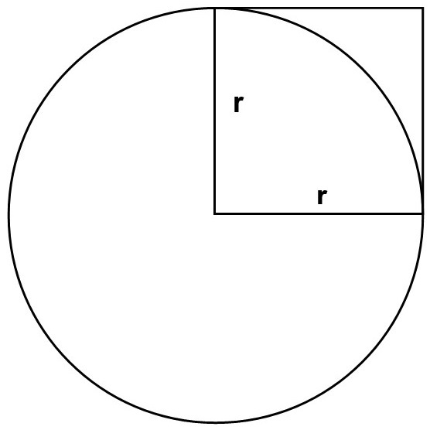
Figure 11-2 The value r² as a unit for measuring the area of a circle
The area of the square with four sides each equaling r is obviously less than the area of the circle whose radius is r. More significantly, the formula requires that some number of squares fit into the circle with radius r. Yet just as you can’t fit a square peg into a round hole, seemingly no definite number of squares will fit into that circular area. The only number that works in this formula is π, an irrational nonrepeating decimal, according to traditional mathematics.
The diagram above shows the difficulty in using a square as a unit of measure for the circle. It was believed that the value of π as an irrational number can never be determined because there is no rational number of squares that will fill the area of a round circle. Also, it shows the difficulty in arriving at an exact value for π, since it is seen as the ratio of the circle to the diameter, and people couldn’t find a way to measure the length of the circle exactly.
Because π was defined as a ratio of Circumference/Diameter, people tried to find a ratio that equaled π. Examples include 22/7 and 355/113. Leibniz and others even created convergent series that closely approximated π. The problem is that none of these ratios or convergent series equaled π exactly. So it was assumed to be an irrational nonrepeating decimal number. Calculating π to 105 trillion digits is an admirable feat of technology, but it gets us no closer to understanding π than does the number 3.1416.

The Rope Experiment
The Rope Experiment provides a different way to measure the length of the circumference of a circle.
Take a circle with a radius (r) of 2 inches and a diameter (d) of 4 inches. By our standard equation for the circumference (C) of a circle, the circumference is: C = 2 * π * r
Given that our radius is 2 inches long, this gives the following value for the circumference of the circle: C = 2 * π * 2
Multiplying this out, we have: C = 4 * π

Given that π is approximately 3.1416, this gives us a value of 12.5664 inches for the circumference of the circle.
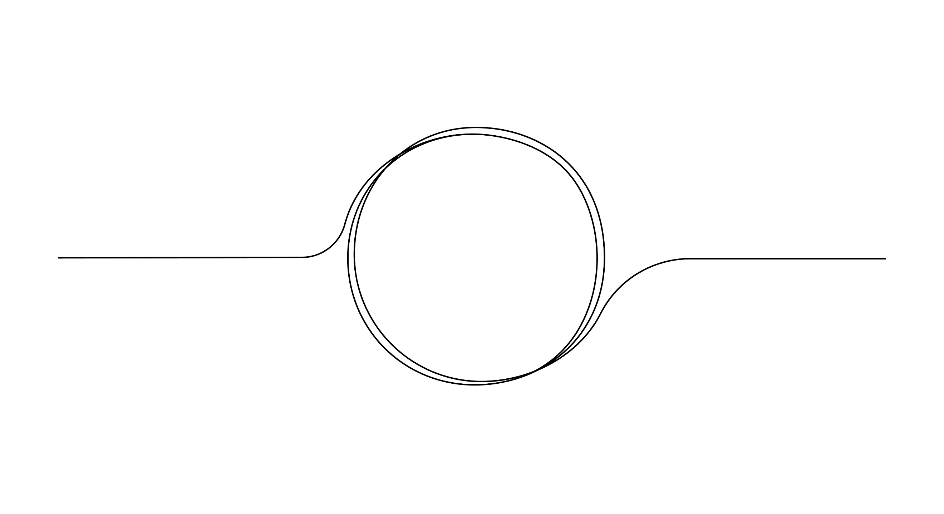
Figure 11-3. A rope being formed into a straight line
Now take a rope and form it into a circle with a radius of 2 inches. This can easily be done by measuring in a straight line from the center of the circle to its edge, which is formed by the rope.

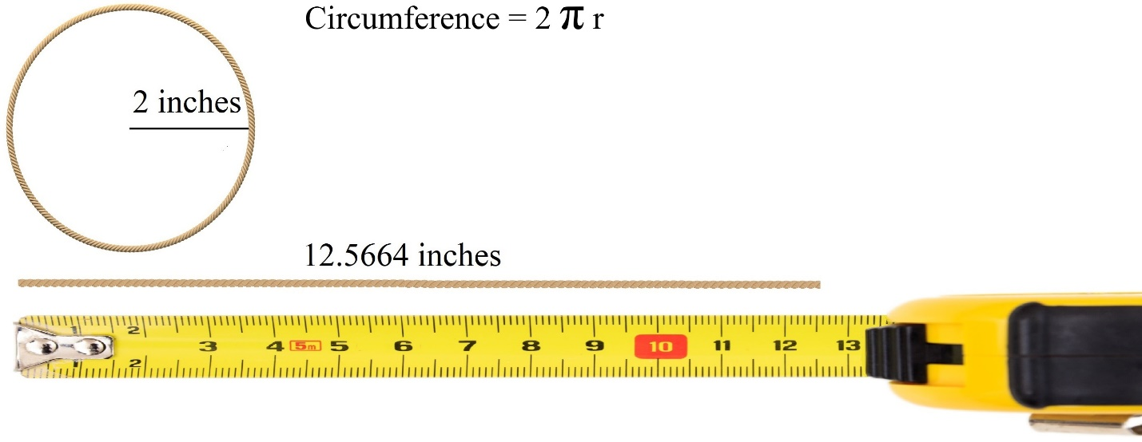
Figure 11-4. Measuring the length of a circumference of a circle with a tape measure
Illustration by Leslie Buchanan
Take the rope that forms the circle and lay it flat. It becomes a straight line of length C. A straight line has measurable, rational length (you can measure it with a ruler or counting units). There is no need to use π in providing the length of a straight line. So C, the circumference, is a rational
number.
Measure the rope with a yardstick or a tape measure. You will find that the length of the rope is right around 12.5 inches, depending on how precise you want to be. Using the approximate value of π as 3.1614 in the formula 2 * π * r, the circumference is 12.5664 inches. What is the difference between 12.5 inches and 12.5664 inches?
Using the traditional value of π for the circumference in the equation 2 * p * r we get an irrational value that can only be approximated because it includes a value (π) with indefinitely many digits that never repeat. Π has been carried out to 105 trillion digits by supercomputers and it never repeats digits.
Using a tape measure, we get a measurable value for length of the rope that is just over 12.5 inches. We can carry this out to any desired level of precision, but it depends on our unit of measurement and the precision of our measuring tool. Given that we are using inches as our unit of measurement, it is unlikely that we would need to carry it out much further than four digits after the decimal. Whether we use a fraction or a decimal value, the measured number we get is a rational number and it does not contain a never ending string of decimal values.
Which value is correct? Between 12.5 and 12.5664, we can say that 12.5664 is a more precise version of 12.5: the same measurement, but one carried out to a greater number of digits.

The Length of the Rope Doesn’t Change When You Lay it Flat
A rope doesn’t change its length when you shape it into a circle, turn it into a hula hoop, shake it up and down, or tie it around a tree. The length of the rope remains constant regardless of its shape. The ratio of a circle's circumference to its diameter is defined by the length of the circular boundary measured in rational units. The result is a rational value, specific to the precision of measurement, not a transcendental abstraction.
Given that we have a measurable, rational length for the rope when it is laid flat, this is the length of the rope. And this is also the length of the rope when it is shaped into a circle. The problem is not with our measurement of the rope – the problem is with our equation for calculating the circumference of a circle.
As a result, I suggest we accept that the value for the circumference of a circle is a rational value. When we measure the length of the rope as 12.5664 in a circle with radius 2, and the length of the circumference is 12.5664, this gives us the equation 12.5664 = 2 * π *2. This equation is equivalent to 12.5664 = 4 * π. Dividing both sides by 4, we have 3.1416 = π. Since we know that the circumference if a circle is a rational, measured value, it follows that π is also rational. Since 3.1416 is the closest rational approximation to the value of pi, we can accept 3.1416 as the actual, rational value for π.
Using our formula:
C = 2 * π * r
we get
π = C/(2 * r) = C/D
where D is the diameter of the circle.
In our example: Π = 12.56/(4) = 3.14
This is close to the standard value for π of 3.1416
If we carry this division out to two more digits of precision: 12.5664/4 = 3.1416
This is the value of π carried out to the first four digits after the decimal point.
Rather than trying to find a single value of π that applies to all situations, we may want to approximate π as closely as necessary given the precision we require in our measurements. If we are carrying our measurement to only two decimal places in our measurement like in the example a value of 3.14 may do just fine. If we need more precision we can measure to a greater number of decimal places. Whatever we do, π remains a rational number, and C/D gives a rational value for π. Some people use 22/7 as a value for π. While this is less precise than 3.1416, it may serve well in some contexts.
The reasoning using ratios and converging series was based on defining π indirectly – through limits and approximations – rather than measuring it directly. The Rope Experiment offers a different approach: by measuring the length of a circular path laid flat, we find that π is a rational, measurable number. Now that we know from The Rope Experiment that π is a rational number, it is time to reexamine our assumptions about how to calculate the area of a circle..

The Area of a Circle is a Rational Number
The formula for the area of a circle is π * r². If we substitute C/D for π in this equation, we get (C/D) * r². Because C is now rational by The Rope Experiment, and we know that the diameter is rational in most situations, it follows that the area of a circle is a rational number. This is a dramatic change from the traditional interpretation of π * r^{2,} according to which the area of a circle is an irrational number with an infinitely non-repeating decimal.
Having a rational value for the area of a circle means that we can reconcile the unit square with circular area. Earlier in this chapter we stated that measurements require a unit of measurement and need to be carried out to some degree of precision. We can apply this idea to the area of a circle: since we have so many digits to choose from, we can carry the calculation of area to as many digits as we like, by measuring the circumference to as many digits as we like, take C/D, and multiplying this value by the radius squared (r²).
The value of 3.1416… as an irrational number was derived by multiple methods. One method was to inscribe and also circumscribe multiple polygons around a circle until the number of polygons approximates the circle, and then divide this value by the diameter of the circle. Another way is to multiply out 22/7. There are other methods that involve convergent series and limits.
In Finite Geometry, π is defined as the measured ratio of a circle's circumference to its diameter, with a rational value such as 3.1416. This measurement can be carried out to any finite degree of precision, but it is not shorthand for an irrational number with an unending series of digits. It is a real, physical quantity, like the meter, and it is based on measurable properties of space.
This method of measuring the circumference of a circle can be compared to the way in which the standard meter in Paris was used to define the length of a meter. Since 1983, this length has been defined by light speed instead of by the standard meter bar. But the idea is the same. We are advocating a physical method for determining the length of the circumference of a circle that generally results in a value of 3.1416. This value may differ according to the precision of the measurement tool. It can be carried out to any degree of precision desired, but it is not shorthand for an infinite series or for an irrational number. The length of the circumference of a circle is now a measurable constant derived from real geometry – the circumference of a circle with known diameter.

The Length of the Meter is Also Defined by a Physical Object or Procedure
Since 1855, the science of metrology has made major advances, with a greatly expanded capability for precision. In 1866, an Act of Congress made the use of the metric system permissible in the United States. In 1889, the United States received a prototype Meter bar from the International Bureau of Weights and Measures, and that became the new standard for the length of a meter. However, in 1960 the science of measurement took a major step forward with the definition of the meter in terms of the wavelength of light from krypton-86. A meter was defined as 1,650,763.73 wavelengths of the orange-red radiation of krypton-86. This definition was promulgated by the French organization called General Conference on Weights and Measures (CGPM).
In 1959, just prior to this definition of a meter, Australia, Canada, New Zealand, South Africa, the United Kingdom and the United States agreed on the length of an international yard, defined in terms of the meter. The international yard is equal to 0.9144 of a meter. Thus, the length of the yard came to be derived from the definition of a meter.
In 1983, the CGPM took another step towards precision by defining the meter as equal to the path length traveled by light in a vacuum during a time interval of 1/299,792,458 of a second. This definition also locked in the speed of light in a vacuum as 1/299,792,458 meters per second. History indicates, however, that this is probably not the final word on the subject.

Measuring Flow in Round Pipes
The value of π also plays a crucial role in flow measurement. There is no escaping the need to measure the area of a pipe when calculating flow. The formula for measuring volumetric flow is:
Q = A * v
Here Q is the volume of flow that passes a specific point in a unit of time. A is the cross-sectional area of the inside of the pipe and v is the average flow velocity. Circular area is calculated using the formula:
Area = π * r².
Because pipes are round, they form a circular area. The formula for the area of a circle is”
Area = π * r²
This means that the formula for Area is a part of most calculations for the flowrate for fluid flowing through a round pipe. Engineers typically use 3.13, 3.1416, or 22/7 as the value for π. They are taught to believe that this gives them an approximation of the area, since we cannot truly know the value of π. But the result of The Rope Experiment is that we can know the actual value for area. The precision required dictates how many digits should be used in a given situation.
Since π * r² is the formula for the cross-sectional area of a pipe, it is important to understand what it represents. The Greek philosopher Plato taught us that mathematics is not about actual squares and circles, and other geometric shapes, but about the ideal shapes that these figures represent. Thus, for example, if the surface of a desk does not have perfectly straight edges, we still feel comfortable using the formula length x width to calculate its area. Another way of saying this is that geometry is about ideal shapes and figures even though the actual objects we are talking about are not ideally round or ideally square.
In the case of pipes that contain fluid to be measured, there are other issues that affect the measurement besides the fact that the mathematics assumes an ideally round pipe. If all pipes were perfectly round, then there would be no issue with using the formula for the area of a circle to calculate their area. But there are multiple factors affecting the roundness of a pipe.
When considering the area of a pipe, it is also important to take into account the fact that pipes are three-dimensional objects. Pipes have an outside diameter (OD) and an inside diameter (ID). It is only the inside diameter of the pipe when cross-sectional area is being calculated.

What is the Inside Diameter of Your Pipe?
Not all pipes are perfectly round. When flowmeters are calibrated, they are calibrated on clean pipes with no sediment or buildup on the walls. Once flowmeters reach the field, they enter a new world where sediment and buildup can occur. This can occur in many ways.
Scaling. When hard water is heated, it can scale when heated, causing a hard, chalky deposit in pipes. This is due to the high levels of calcium and magnesium in hard water. This scaling hinders water flow, reduces appliance efficiency, and increases energy costs. Over time, it narrows the pipe’s diameter, increasing the chances of blockages and leading to more frequent maintenance and potential replacements. Chlorine and disinfectants in municipal water supplies can react with pipe materials, degrading the pipe’s inner surface.
Corrosion. Corrosion in water pipes is the result of the interaction of water, oxygen, and other elements of a pipe’s environment. Corrosion can weaken the interior and exterior of the pipes. Aging pipes are subject to corrosion when exposed to oxygen and water. This is especially true of pipes made from metals like iron, steel, or copper. This process degrades the material, forming rust and releasing sediments into the water supply. The weakening integrity increases the risk of leaks and can lead to significant water damage and costly repairs. Rust and other compounds can build up on the inner pipe wall, reducing the internal diameter of the pipe. This can restrict the flow and increase pressure loss.
Temperature Changes. Extreme temperature changes can cause minerals to precipitate and solidify, forming deposits on the inner surfaces of pipes. In hot water systems, heat can induce calcium carbonate precipitation. These deposits can reduce pipe diameter, increase pressure, and decrease water flow.
Inside diameter is especially important for ultrasonic flowmeters, which use the distance from one side of the pipe to the other in their computation of flowrate. While this can be an issue for inline ultrasonic meters, it is also important for clamp-on ultrasonic meters. Clamp-on ultrasonic meters base their flowrate calculations on a signal sent through the pipe wall and to the other side of the pipe. Buildup in the pipe can contribute to the attenuation of the signal. It can also affect the calculation of the flowrate.
Of course, there are many other issues providing uncertainty in flow measurement. These include flow profile, cavitation, turbulence, repeatability, two-phase flow, and many more. All these issues need to be addressed, and this is what manufacturers do in their research and development efforts, using the math that is available to them. Having a rational value for the area of a circle may reduce or eliminate one of those uncertainties.

Application to Mass Flow
In chapter 4, we learned that we can derive mass flow from volumetric flow through the following equations:
ṁ = ρ x Q
Here ṁ = mass flowrate (kg/s)
ρ = fluid density
Q = volumetric flowrate (m³/s)
To get the density measurement, you need:
- An external density measurement, such as with a densitometer, or
- A calculated density based on pressure, temperature, and fluid composition (especially for gases)
This is true for flowmeters such as differential pressure and vortex that provide mass flow by measuring volumetric flow and then using density values to determine mass flow. Coriolis and thermal measure flow differently, even though they may also output volumetric flow. However, even Coriolis and thermal flowmeters need to know the pipe size, and hence the internal diameter of the pipe, in order to determine mass flowrate.
Since the cross-sectional area of a pipe is a critical part of most flowrate measurements, whether volumetric or mass, it follows that knowing a pipe’s cross-sectional area is an important part of most volumetric and mass flow measurements. Having a rational value for calculating this area is another step towards producing accurate and repeatable flow measurements.

Calculus and Measuring the Area Under a Curve
Besides measuring the area of a circle, measuring the area under a curve has proved one of the most difficult tasks for a geometry based primarily on straight lines. Calculus provides one way to measure this area. Calculus finds the area under a curve using the definite integral:
∫ₐᵇ f(x) dx
The definite integral represents the limit of a sum of infinitely many rectangles, each with:
Height: f(x)
Width: dx (an infinitesimal)
Calculus draws a rectangle under the curve, where one point of the rectangle intersects with the curve. It then draws a series of increasingly small rectangles with width (dx). The area under the curve is the limit of the sum of this process of drawing ever narrower rectangles. Calculus takes the limit of the number of rectangles as that number approaches infinity and as their width approaches zero.
While calculus does not claim to actually complete an infinite process, it does rely on the concept of infinity in other ways. In particular, calculus relies on the idea that the number line is made up of infinitely many arealess points. Otherwise the idea of “approaching a limit” makes no sense. Calculus relies on the idea that between any two points are infinitely many other arealess points. If calculus reaches a gap in the number line, its approach to the limit of a series stops. In calculus, the series of rectangles must come arbitrarily close to the limit, which means for any position the rectangles reach in relation to the limit, it must be possible to them to get even closer.
We saw above that the assumption that there are infinitely many points in the line leads to Zeno’s Paradox and other paradoxes. How then should we evaluate the area under a curve?

Finite Point Geometry and the Area Under a Curve
In Finite Point Geometry:
- Points lie on the line, not in the line.
- There is no limit to the number of points on a line, but each must have a specified area.
- Each point contributes a finite amount of area and serves as a unit of measurement.
Finite Point Geometry evaluates the area under a curve in the following way:
Consider a curve that extends two inches in width, say from 0 to 2.
Specify a number of points on a line that extends underneath the curve (e.g., on the x axis). This implies a width for each point – in this case, 1/10 of an inch.
Draw a vertical line from each point along the line to a corresponding point on the curve.
Measure the lengths of all these lines and add them together. Divide that number by the number of points (in this case 20). That is the average height of the curve. Now multiply the length of the line (2 inches) by the average height of the curve. This gives you the area under the curve.

This method does not require assuming an infinite number of points in or on the line. It is a method for constructing the area under a curve, and it provides a rational alternative to calculus.
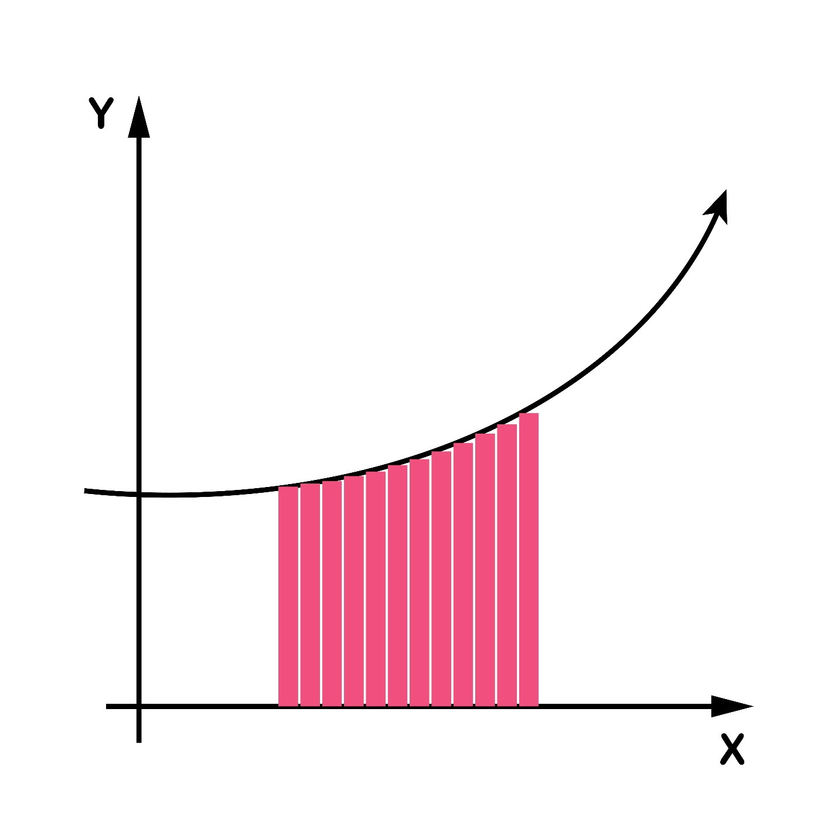
Figure 11-5. Drawing wide lines from the base to corresponding points on the curve to obtain
the area under the curve

